COMPUTER BASED TEST

WEB APPLICATION

### 

### **A Project Work Synopsis**

# Submitted in the partial fulfillment for the award of the degree of

# BACHELOR OF ENGINEERING

### **IN**

### **CSE-BIG DATA ANALYTICS**

### **Submitted by:**

### **P. VINAY KUMAR**

**20BCS4467**

### **Under the Supervision of:**

### **Gurpreet Singh Panesar**



### **CHANDIGARH UNIVERSITY, GHARUAN, MOHALI - 140413,**

**PUNJAB**

**FEBRUARY,2022**

# Table of Contents

# Acknowledgement

# Abstract

# Introduction

# Results

# Conclusion

# Future Scope

# References

**ACKNOWLEDGEMENT**

We have taken efforts in this project. However, it would not have been possible without the kind support and help of many individuals. I would like to extend my sincere thanks to all of them. We are highly indebted to our mentor for their guidance and constant supervision as well as for providing necessary information regarding the project and also for their support in completing the project.

**ABSTRACT**

The main objective of this project is to provide students an easy way to learn from a quiz. This project helps the students to write their exams on an online portal and save their scores for reference. With the growing fascination towards web development many people started learning html, css, javacript we have come up with this small quiz which helps users to recall their fundamentals of the topics required for web development. if find it difficult to answers the questions the web page also contains link to amazon store which contains the books related to web development and we also provided link to the link w3 school’s were you can have an instant practice on the codes and strengthen your fundamentals.

In our day-to-day life, we come across various examination results such as school exam results, competitive exam results, college semester exam results, etc. The technologies used in the creation of a quiz maker are HTML, CSS, JavaScript Software Requirements and Visual Studio Code.

**INTRODUCTION**

* In this program [Quiz App with Timer], there are three layers or boxes, and these boxes shown one by one on a particular button clicked. At first, on the webpage, there is shown a button labeled as “Start Quiz” and when you clicked on that button, then the info box appears with popup animation.
* In this infobox, there are some rules of the quiz and two buttons labeled as “Exit” and “Continue”. When you clicked on the Exit button, the info box will be hidden but when you clicked on the Continue button, then the Quiz Box appears.
* In the Quiz Box, there is a header with a title on the left side and a timer box on the right side. This timer starts decrement from 15 to 0 sec and there is also shown a timeline indicator that is sliding from the left to right side according to the timer. If the user selects an option between 15 to 0 sec, the timer will be stopped and all available options will be disabled.
* If the user selected option is correct, the selected option color, background color changed to green and there is also shown the tick icon to inform the user that the selected answer is correct. If the user selects an option that is incorrect, the selected option color, background color changed to red and there is shown the cross icon to inform the user that the selected option is incorrect and the correct option will be automatically selected.
* If the user doesn’t select an option between 15 to 0 sec, the timer will be stopped once it comes in 0 and the correct option of that question will be selected automatically. After that, there is the next button to show the next question, and there is a total of five questions on this Quiz.
* In the end, the result box will be appeared and shown the user score and two buttons [Replay Quiz, Quit Quiz], if the user clicked on the replay quiz button, the quiz will again start with the number 1 question, and the score of the user will be 0 but if the user clicked on the quit quiz button, the current window will be reloaded and the quiz starts from the begin.

**RESULTS**



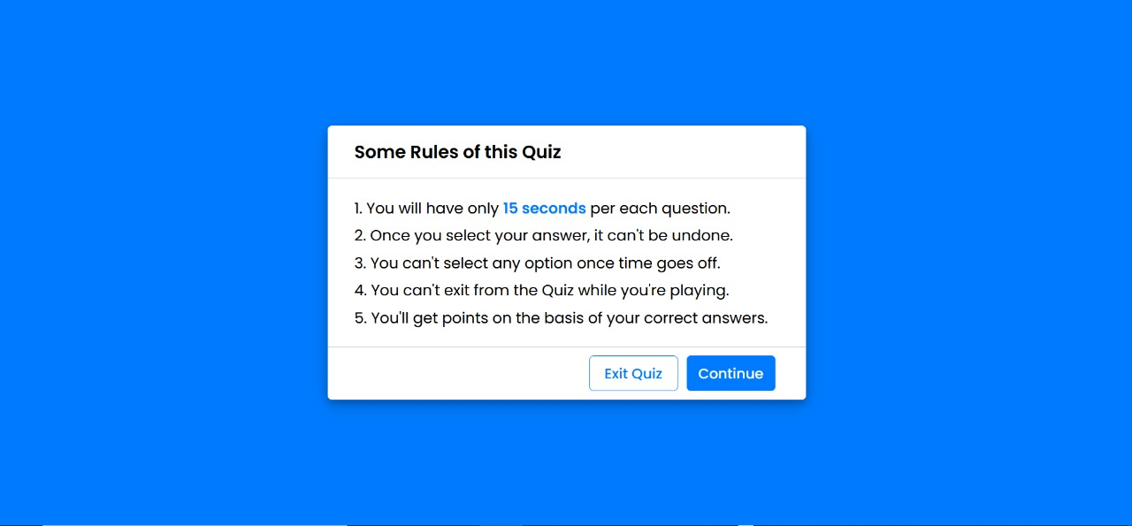

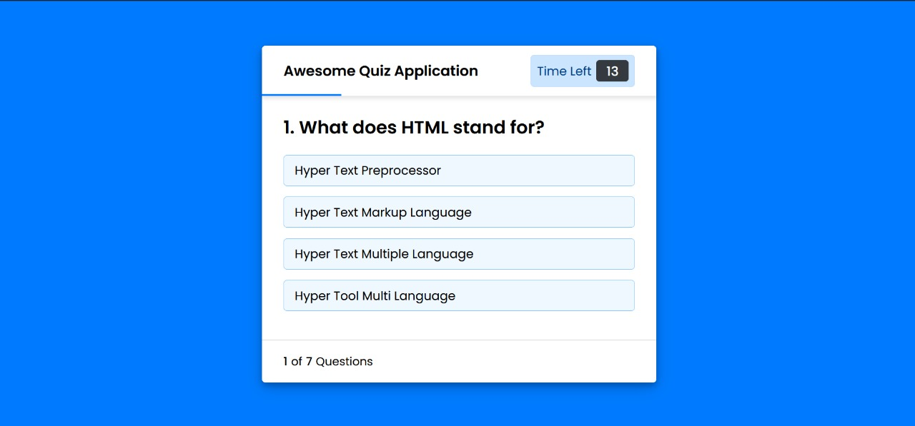

**CONCLUSIONS**

* After extensive testing and the final validation, it was concluded that the project is successful in carrying out all the functionalities mentioned throughout this report.
* Online Quiz is a web application. The key concept is to minimize the amount of paper and convert all forms of documentation to digital form. It can observe that the information required can be obtained with ease and accuracy in the computerized system. The user with minimum knowledge about computer can be able to operate the system easily.

**FUTURE SCOPE**

* When it comes to Web Development, HTML plays very important role since beginning and today without **HTML**, **CSS** and javascript, website development would have been little difficult.
* These are known as future of web Technology.
* JavaScript is extremely popular that it makes interactive web pages. In fact, for some people, front-end development means JavaScript development services.
* According to the trends evaluated by W3Techs, JavaScript is the top-notch client-side programming language.
* We also hope to implement as an app on various other mobile platforms.
* In the future we can place the system on the cloud so the maintenance of the data can be more secure and efficiently stored.
* Add a feature which tries to enhance or improve the students knowledge on the subject from the root levels.

**REFERENCES**

<https://www.w3.org/standards/webdesign/htmlcss>

<https://www.udemy.com/course/build-a-quiz-app-with-html-css-and-javascript/>

<https://www.youtube.com/watch?v=riDzcEQbX6k>

<https://www.freecodecamp.org/news/html-css-and-javascript-explained-for-beginners/>